|  |  |
| --- | --- |
| 翻译前字数 | 565 |
| 目录 | Unity Manual/Unity Services/Unity Analytics/Setting Up Analytics |
| 链接 | https://docs.unity3d.com/540/Documentation/Manual/UnityAnalyticsOverview.html |

**Setting Up Analytics**

**建立Analytics**

To get started with Unity Analytics, you must first link your game to a **Unity Services Project ID**. A Unity Services Project ID is an online identifier which is used across all Unity Services (Ads, Multiuser, IAP, etc). These can be created within the services window itself, or online on the [Unity Services website](https://developer.cloud.unity3d.com/). The simplest way is to use the Services window within Unity, as follows.

要开始使用Unity Analytics，首先需要将您的游戏链接到Unity服务项目的ID。Unity服务项目的ID是跨所有Unity服务（广告，多用户，IAP等）的在线标识符。可以在服务窗口内创建，或者在[Unity Services website](https://developer.cloud.unity3d.com/)在线创建。最简单的方式是在Unity内使用服务窗口，如下：

**Step 1. Link your project with a Unity Services Project ID.**

**步骤1.链接您的项目到Unity服务项目的ID。**

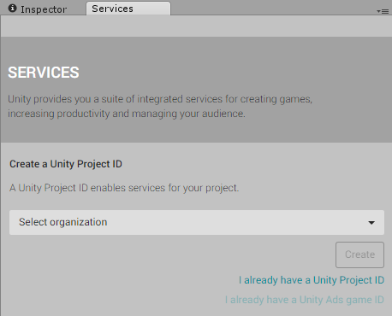The Services Window

服务窗口

Open the Services Window, by going to the menu: **Window** > **Unity Services**, or click the cloud button in the toolbar. https://docs.unity3d.com/540/Documentation/uploads/Main/CloudButton.png

打开服务窗口，通过菜单: **Window** > **Unity Services**，或者点击在工具栏的云按钮。

You will be given the option to create a new Project ID or select an existing one.

选择创建一个新的项目ID或者选择一个已存在的项目

If this is the first time you are connecting your project to Unity Services, you’ll neet to create a new project ID. The organization is typically your company name. The project name for the new Services ID will automatically be taken from the name of the Unity Project you’re currently working on.

如果您第一次连接项目到Unity服务，您将需要创建一个新的项目ID。组织通常是您的公司名称。新ID的项目名程将自动采用您正在工作的Unity项目名。

Although the name for new Unity Services Project IDs are automatically picked from the project’s name, you can change the name later if you like. This can be done in the Settings section of the services window.

虽然新的Unity服务项目ID会自动获取项目名称，但如果您需要可以在之后更改。可以从服务窗口的设置部分来完成。

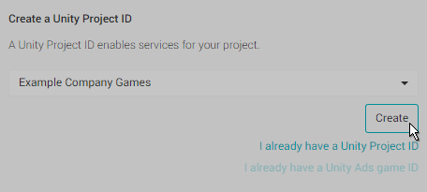Creating a new Unity Services Project ID

创建一个新的工程ID

Alternatively, if you have already set up a Unity Services Project ID for this project you can select the organisation and project name from your list of existing projects here. You may have already set up a Unity Services Project ID if you have used one of the other Unity services with this project already, such as Unity IAP, Multiplayer, Ads, or Cloud Build.

或者，如果您已经为此项目设置了Unity服务项目的ID，您可以从组织和工程名列表中选择您的项目。如果您已使用了一个其他Unity服务，例如Unity IAP,多玩家,广告和云构建，那您或许已经设置了Unity服务项目的ID。

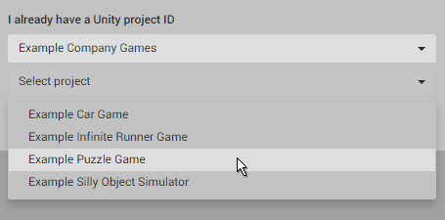Selecting an existing project

选择一个已存在的项目

**Step 2. Enable Analytics for this project.**

**步骤2.为此项目启用Analytics**

In the Services window, select “Analytics” and then click the “Off” button to toggle it **On**. If you haven’t already done so, at this stage you will need to complete the mandatory Age Designation field for your project. (Again, you may have already done this for a different Unity Service, such as Ads). This age designation selection will appear in the Services window.

在服务窗口中，选择“Analytics”然后点击“Off”切换为打开状态。如果您没有这样做，那么您需要为您项目强制填写年龄指定字段。（同样，您可能已经为不同的Unity服务执行了此操作，例如广告）。年龄指定将出现在服务窗口上。

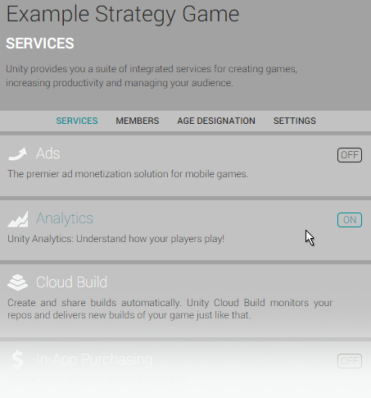Enabling Analytics within your project

在您的项目中启用Analytics

**Step 3. Hit Play in your project to validate the analytics link.**

**步骤3.点击播放以验证Analytics的链接**

The Unity Editor can act as a test environment to validate Analytics integration. When you press the Play button, the Editor sends data (an “App Start” event) to the analytics service. This means you can test your analytics without having to build and publish your game.

Unity编辑器也可以作为验证Analytics集成的的测试环境。当您按下了播放按钮，编辑器会发送数据（一个“App Start”事件）到Analytics服务。意味着您可以不用构建并发布游戏来测试您的Analytics。

Once you have pressed play, you can check that your project was validated by going to the Analytics Dashboard for this project. To get there, in the services window, click Services -> Analytics -> Go To Dashboard.

一旦您按下了播放，您可以访问项目Analytics的Dashboard中检查您的项目是否已验证。要访问此项目的AnalyticsDashboard，从服务窗口中点击Services -> Analytics -> Go To Dashboard.

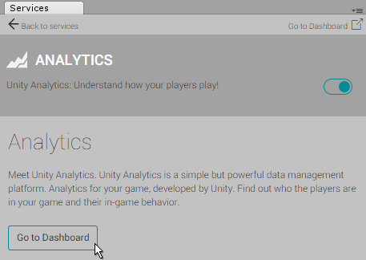The “Go To Dashboard” button in the Analytics section of the Services window

“Go To Dashboard”按钮在服务窗口的Analytics部分。

The dashboard opens in a web browser. You’ll see three headings under your project’s name: Overview, Basic Integration and Advanced Integration. Click **“Basic Integration”**, then directly underneath, click step 3: **“Play to Validate”**. If your project was set up correctly, you should see a table containing an entry showing an “appStart” event, along with the date and time, as well as your current editor platform and version number.

Dashboard打开在网页浏览器中。您将在项目名称下看到三个标题：概述，基本集成和高级集成。点击“基础集成”，在下面直接点击步骤3: **“Play to Validate”**。如果您的项目已正确的简历，您将看到其中包含一个“appStart”事件的的表，其中包含日期和时间，以及您当前编辑器平台和版本号。

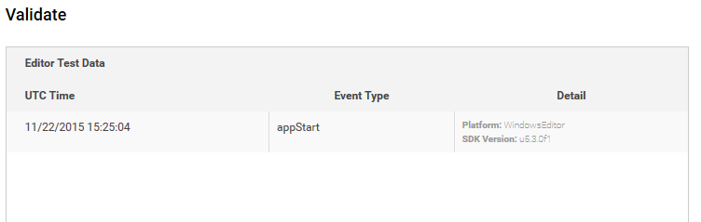The Validate Test Data Table on the Analytics Project Dashboard

Analytics Project Dashboard上验证的测试数据表